**Week – 7**

**Hands on Lab Questions**

1. **Table: Students**

|  |  |  |  |  |  |  |  |
| --- | --- | --- | --- | --- | --- | --- | --- |
|  | **Student_ID** | **Firstname** | **Lastname** | **Age** | **Gender** | **Grade** |  |
| 1 | Rakesh | Shrestha | 19 | Male | A |
| 2 | Binita | Bhandari | 21 | Female | B |
| 3 | Bobby | Sherpa | 20 | Male | C |
| 4 | Sagar | Parajuli | 22 | Male | A |
| 5 | Prajina | KC | 21 | Female | B |

Queries:

* 1. Retrieve all data from the Students Table

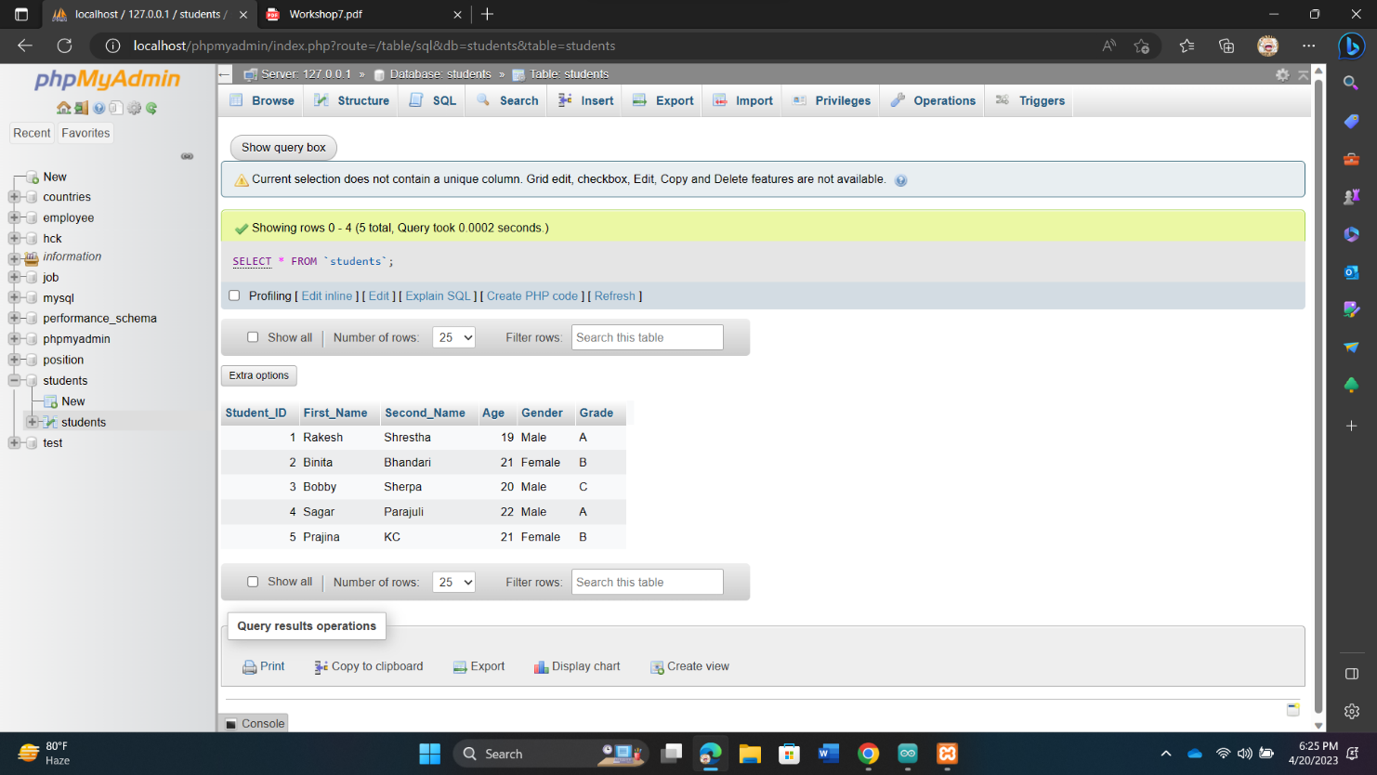

* 1. Retrieve first name and last name of all students

* 1. Retrieve only the students who have a grade A

* 1. Retrieve only the students who are older than 20

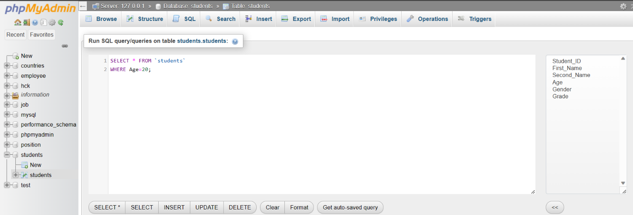

* 1. Retrieve the count of male and female students

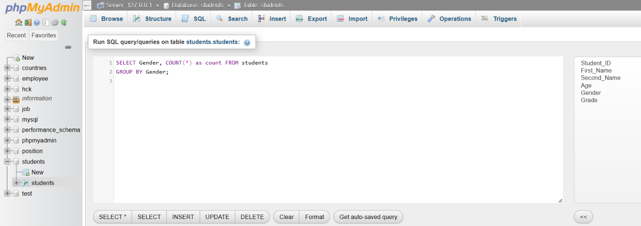

* 1. Update the grade of a specific student (e.g. StudentID=3)

* 1. Increment the age of all male students by 1

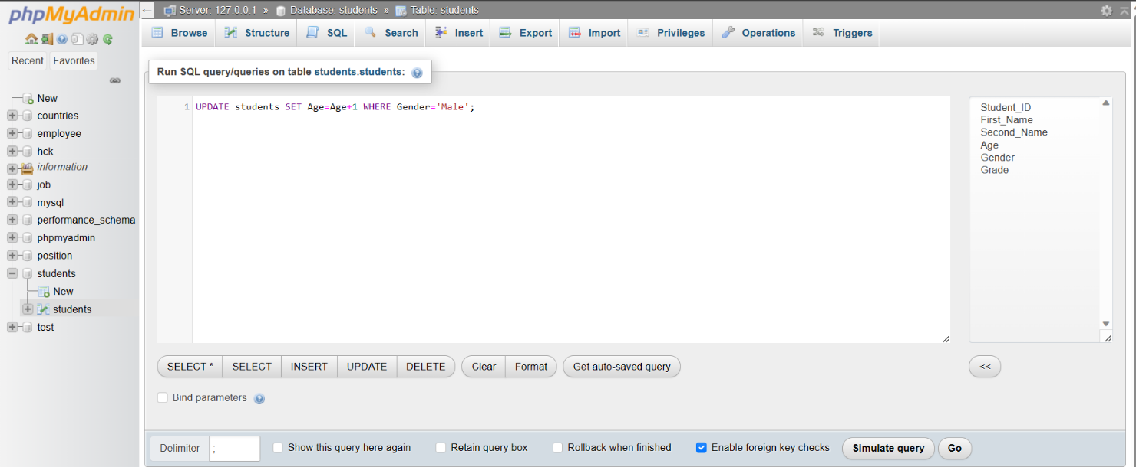

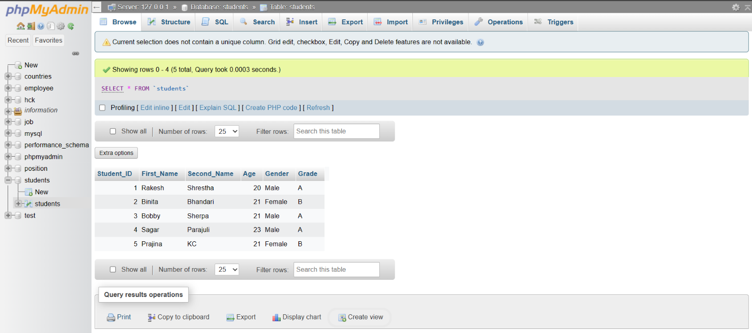

* 1. Update the grade of all female students who have a grade of 'B' to 'A'

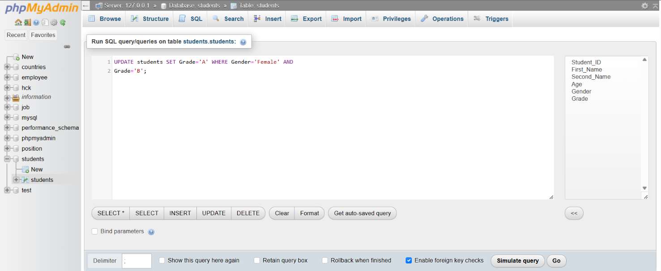

1. **Table: Customers**

**Customer_ID Firstname Lastname Age Gender Email**

|  |  |  |  |  |  |
| --- | --- | --- | --- | --- | --- |
| 1 | Kabir | Sharma | 25 | Male | kabir@gmail.com |
| 2 | Haris | Shrestha | 30 | Male | haris@gmail.com |
| 3 | Deepti | Singh | 26 | Female | deepti@gmail.com |

**Table: Orders**

**OrderID CustomerID OrderDate Total**

|  |  |  |  |
| --- | --- | --- | --- |
| 1 | 1 | 2023-04-06 | 1000 |
| 2 | 1 | 2023-04-01 | 3000 |
| 3 | 2 | 2023-03-22 | 3500 |
| 4 | 3 | 2023-04-04 | 2300 |

**Table: OrderItem**

|  |  |  |  |  |
| --- | --- | --- | --- | --- |
| **OrderItemID** | **OrderID** | **ProductItems** | **Quantity** | **Price** |
| 1 | 1 | Product A | 2 | 1200 |
| 2 | 1 | Product B | 3 | 1345 |
| 3 | 2 | Product C | 4 | 1360 |
| 4 | 3 | Product D | 5 | 950 |
| 5 | 3 | Product E | 1 | 1125 |
| 6 | 4 | Product F | 2 | 1780 |
| 7 | 4 | Product G | 1 | 1560 |
| 8 | 3 | Product H | 3 | 1220 |

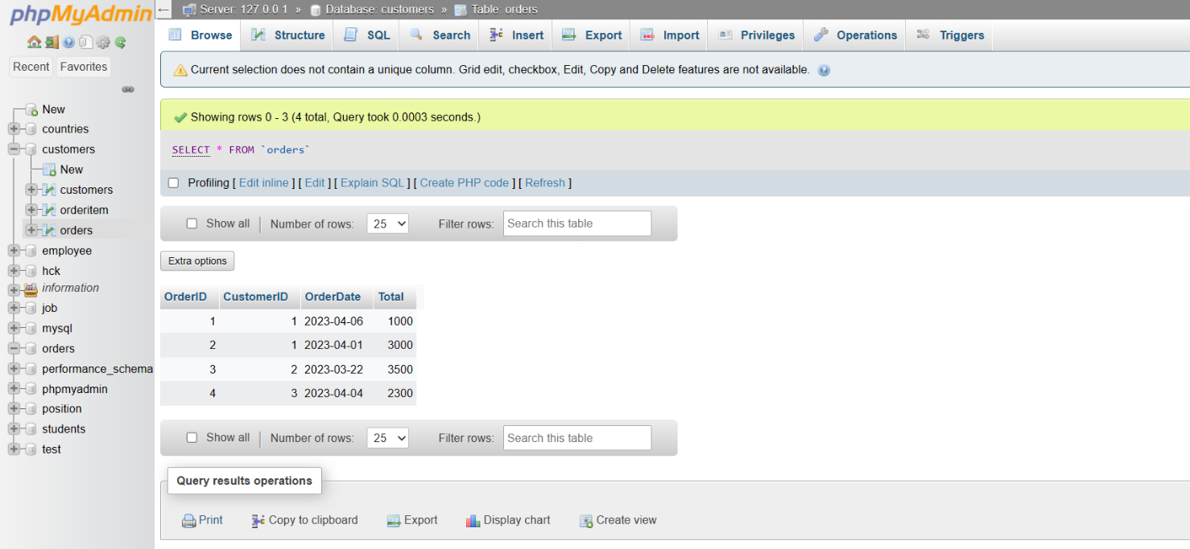

Queries:

1. Retrieve all orders along with the customer details

1. Retrieve all orders along with the customer details and order items

1. Retrieve the customer details for a specific order (e.g. OrderID=2)

1. Retrieve all orders for a specific customer (e.g. CustomerID=1)

1. Retrieve the total revenue generated by each customer

